**Chapter 1**

**INTRODUCTION**

* 1. **Background**

Road safety continues to be a major developmental issue, a public health concern and a leading cause of death and injury across the world, killing more than 1.35 million globally as reported in the Global Status report on Road Safety 2018 with 90% of these casualties taking place in the developing countries and 11% alone being accounted for by India.

As per the Report on Road accidents in India 2019, the accident related deaths in India in 2019 were 1,51,113 in number. It is indeed a matter of great concern that despite the continuing efforts of the Government in this regard and our commitments for halving fatalities we have not been able to register significant progress on this front.

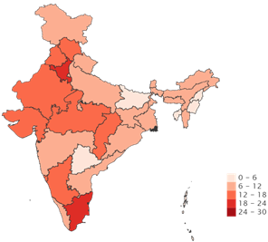Ministry of Road Transport and Highways has been taking multiple initiatives including those related to vehicular and road engineering as well as educational measures for raising awareness in the field of Road Safety. The year 2019 saw the culmination of our efforts in the field of Road safety through the enactment of the Motor Vehicle Amendment Act 2019, which among other things, provides for a stiff hike in penalties for traffic violations with the aim of bringing in discipline and a responsible attitude amongst road users.

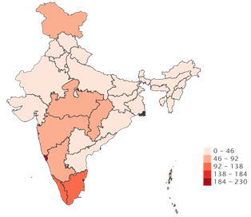

Figure 1.1: Road accidents Lakhs /Population Figure 1.2 : People Killed Lakhs /population

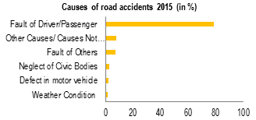

Figure 1.3: Accident Summary report

Majority of accidents (78.4%) are caused due to driver’s fault. This includes over speeding, driving under the influence of alcohol or drugs, and hit and run cases.

Other causes of road accidents include fault of others (7.1%) such as fault of cyclists, pedestrians or drivers of other vehicles. Fewer accidents are caused due to neglect of civic bodies (2.8%), defect in motor vehicle (2.3%), and poor weather conditions (1.7%).

**1.2 Introduction to LoRa**

LoRa (Long Range) is a protected advanced remote information correspondence innovation. LoRa is a long-run remote correspondence convention that contends with other low-power wide-area network (LPWAN), for example, narrowband IoT (NB IoT) or LTE Cat M1. Contrasted with those, LoRa accomplishes its very long range availability, conceivable 10km+, by exchanging off information rate. This innovation is a rising innovation for the exchange of information in executing sensor organizes answers for sensor information accumulation and transmission from end hubs to base stations.

LoRa uses permit free sub-gigahertz radio recurrence groups like 169 MHz, 433 MHz, 868 MHz (Europe) and 915 MHz (North America). LoRa empowers long-extend transmissions (in excess of 10 km in country zones) with low power utilization The innovation is exhibited in two sections: LoRa, the physical layer and LoRaWAN (Long Range Wide Area Network), the upper layers.

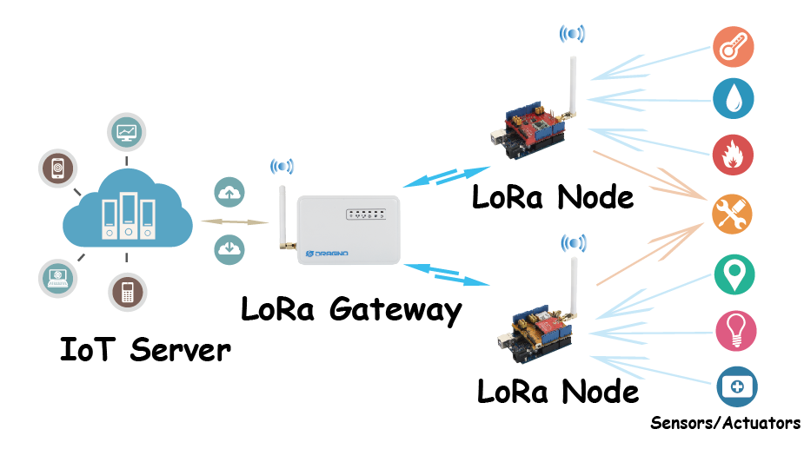Figure 1.4: Lora Architecture

## 1.3 Summary

Road traffic accidents, according to statistics, are the primary cause of death by injury. An accident can occur for a variety of reasons, including a lack of training institutions, the use of a cell phone while driving, inexperienced drivers, driving while inebriated, poor road conditions, overloading, and poor traffic management. However, the majority of the time, it has been noticed that deaths in road accidents are caused by the ambulance arriving late to the accident spot. Although the harm is usually minor and we are able to preserve the lives of those who are impacted, the injuries can become deadly owing to the rescue team's late arrival. We will briefly explore various road accident detection strategies in this suggested project. These techniques use IoT,Lora, Web, Blynk, GPS, Vibration Sensor and Tilt Sensor.

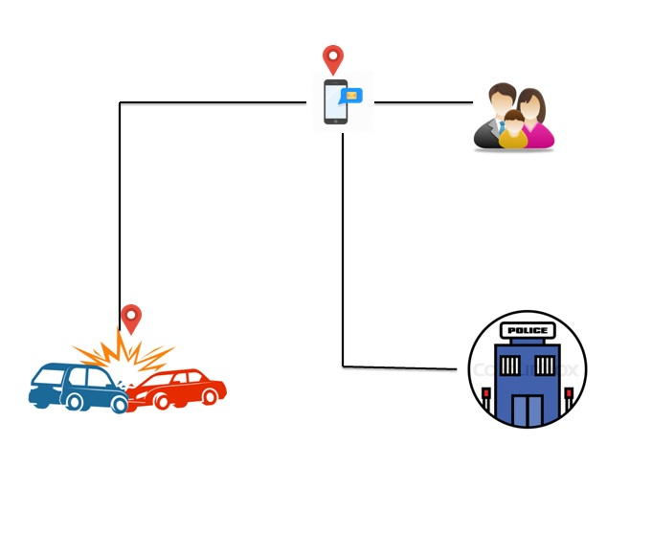

Figure 1.5: Block diagram of proposed prototype

As shown in figure 1.4 the proposed system is an attempt to make use of IoT concept to detect and alert the accident events, accidents are detected by means of sensors and information is stored in centralized server by invoking server side script, the script shows all the information in Mysql database, this centralized database is accessible to various organizations by means of dashboard, using blynk app notification will be sent to family members phone.

**Chapter 2**

**LITERATURE REIVEW**

**2.1 Introduction**

When considering the content to include in our literature review it is important to reflect on our purposes which we wish to address when including references to the work of others. The multiple purposes of the literature review which appears in our thesis or dissertation can be categorized are as follows:

* It provides a historical background for our project.
* It gives an overview of the current context in which our thesis is situated by referring to contemporary debates, issues and questions in the field.
* It includes a discussion of relevant theories and concepts which underpin our thesis.
* It introduces relevant terminology and provides definitions to clarify how terms are being used in the context of our own work.
* It describes related research in the field and shows how our work extends or challenges this, or addresses a gap in work in field.
* It provides supporting evidence for a practical problem or issue which our thesis is addressing, thereby underlying its significance.

**2.2 Accident detection**

Authors of the paper [4] recommend to use vibration sensor at vehicle side and based on the status of the vibration sensor they will draw a conclusion regarding accident.

Authors of the paper[8] proposes to use tilt sensor to be mounted on vehicle and take decisions based on the values, along with vehicle inform also proposes to track heart beat information of the users to understand severity of the accident.

Authors of the paper [9] propose to use ultra sonic sensor to detect range between vehicles and take actions based on the range values returned by the sensor.

**2.2 Accident prevention**

Authors of the paper [1] suggest detecting drowsiness of the driver by tacking the eye blink information and alerts driver if downiness is detected.

Authors of the paper [2],[3],[5],[8] have proposed to use speed detection and traffic rule violation procedures of the vehicle and attempts to inform concerned authorities to take action on such drivers in early state and hence accident could be avoided.

**2.3 Accident alerting**

Authors of the paper [6],[9],[5] suggests to fetch geo location of the accident using GPS and upload the information to concerned authorities using wifi network and also Bluetooth.

Papers from [10] to [17] lights on importance of LoRa technology in collecting agricultural parameters and taking decisions concerned with crops, these papers pays attentions to how one could build WSN using LoRa,advtanges of open frequency band in data collection techniques.

**2.4 Papers referred**

*[1] Arjun K., Prithviraj and Ashwitha A. (2017), “Sensor Based Application for Smart Vehicles”, International Journal of Latest Trends in Engineering and Technology, 8 (1), pp. 526-532.*

The authors of this research present the EBM (Eye Blink Monitoring) technology, which warns the focus when the person is drowsy. An embedded system that monitors head motions and eye movements relies on the psychological state of focus to inform drivers who are in the sleep cycle stage of tiredness. The outcomes of the system are unaffected by a simple eye blink.

*[2] Rangan P. R. (2017), “Vehicle Speed Sensing and SmokeDetecting System”, International Journal of ComputerScience and Engineering, pp. 27-33.[3] Aishwarya et al. S. R. (2015), “An IoT Based AccidentPrevention & Tracking System for Night Drivers”,International Journal of Innovative Research in Computerand Communication Engineering, 3 (4), pp. 3493-3499.*

Researchers have developed an Automated Speed Detection System in this study that can detect a vehicle's speed and, if over speeding occurs, remove the vehicle's license number and mail it to a Toll Plaza for a fine. In this case, the Doppler Effect is used to measure the speed. When over speeding is detected, a camera captures a vehicle's image.

[3] Malik et al. (2014), “Automated Over Speeding Detectionand Reporting System”, IEEE Xplore, pp. 1-7.[5] Shabibi L. A., Jayaraman N. and Vrindavanam J. (2014),

In this paper the researchers conceived and built a unique system that can easily recognize speed violations on roadways and assist drivers in adhering to traffic regulations by keeping a speed within the authorized speed limit. RFID (Radio Frequency Identification), GSM (Global System for Mobile), and PIC (Personal Identification Code) are all components of the designed system (18F45K22). This technique has given dependable, low-cost, and efficient results.

*[4] Shabibi L. A., Jayaraman N. and Vrindavanam J. (2014),“Automobile Speed Violation Detection System using RFIDand GSM Technologies”, International Journal of AppliedInformation Systems, Vol. 7, No. 6, pp. 24-29.*

The authors proposed a novel Vibration Sensor Device to be installed on the vehicle. If an accident occurs, vibration is engaged, and the location of the car is determined using a GPS finder. The incident was immediately reported to Patrol and Life Support so that the accident could be recovered and the suspect could be followed using a GPS tracker.

*[5] Shabibi L. A., Jayaraman N. and Vrindavanam J. (2014),“Automobile Speed Violation Detection System using RFIDand GSM Technologies”, International Journal of AppliedInformation Systems, Vol. 7, No. 6, pp. 24-29.*

The authors in this paper have proposed a system for detecting aggressive driving on highways and alerting traffic authorities if a violation is detected. Many procedures necessitate human attention and involve numerous attempts that are difficult to perform. Researchers wanted to develop a technology for early detection and alert of unsafe vehicle during patterns connected to rash driving in this publication.

*[6] Author:Hossam M. Sherif, M. AmerShedid, Samah A. Senbel,” Real Time Traffic Accident Detection System using Wireless Sensor Network”,Published in: International Conference of Soft Computing and Pattern Recognitionconference: Dec 2014*

Automatic vehicle accident detection is a life saving application that is vital in today’s high speed motorways. In case of motorway accidents, notification to the proper authorities must be done efficiently and expediently. The main objective of this paper is to create a Real Time Traffic Accident Detection System (RTTADS) using Wireless Sensor networks (WSN) and Radio Frequency Identification (RFID) Technologies. This paper explains the hardware prototype setup for RTTADS, the algorithms used, the advantages and the limitations of the entire system. Also the configuration of the setup and application software is elaborated. Sensors installed in a vehicle detect the accident location, the vehicle’s speed just before the accident and the number of passengers in the vehicle. The sensors then send an alert signal to a monitoring station. The monitoring station, in turn, tracks the location where the accident has occurred and directs casualty alert to the authorities concerned.

*[7] Author:Venkata Krishna Kota, Nagendra Kumar Mangali,” Automated Accident Detection and Rescue System”, Thirumal Kumar Kanakurthi Published in: WiSPNETConference.conference: 2017*

Vehicle accidents cause lot of damage. Early detection and timely action will help a lot in accident situations. Researchers proposed methods to analyze vehicle mounted sensor data to detect accidents. To get a big clear picture, we need to correlate and analyze pieces of sensor data instead of analyzing them independently. Along with it, if we also analyze traveler’ sheath data, it will be helpful to take rescue actions. It may not be straightforward to correlate and analyze all these datasets in real time. A big system and framework is required to-do so. An architecture and design methodology is proposed in this paper to analyze the data provided by the vehicle mounted sensors and health data sent by passenger’s wearable devices to detect accidents in real time. After detecting the accidents, system assesses the impact of the accident. Then it either alerts relevant people for rescue action or it does needful actions (as described by the domain experts) on its own.

*[8] Nicky Kattukkaran, Arun George,” Intelligent Accident Detection and Alert System for Emergency Medical AssistanceAuthor” Published in: International Conference on Computer Communication and Informatics conference: Jan 2017*

Road accidents rates are very high nowadays, especially two wheelers. Timely medical aid can help in saving lives. This system aims to alert the nearby medical center about the accident to provide immediate medical aid. The attached accelerometer in the vehicle senses the tilt of the vehicle and the heartbeat sensor on the user’s body senses the abnormality of the heartbeat to understand the seriousness of the accident. Thus the systems will make the decision and sends the information to the Smartphone, connected to the accelerometer and heartbeat sensor, through Bluetooth. The Android application in the mobile phone will sent text message to the nearest medical center and friends. Application also shares the exact location of the accident that can save the time.

*[9]Usman Khalil and Tariq Javid,” Automatic Road Accident Detection Techniques: A Brief Survey”Published in: 3rd International Conference on Advanced Computing and Communication Systems conference: Jan 2016*

A large number of precious lives are lost due to road traffic accidents every day. The common reasons are driver’s mistake and late response from emergency services. There is a need to have an effective road accident detection and information communication system in place to save injured persons. A system that sends information messages to nearby emergency services about the accident location for timely response are absolutely indeed. In research literature, a number of automatic accident detection systems are proposed by numerous researchers. These include accident detection using smart phones, GSM and GPS technologies, vehicular ad-hoc networks and mobile applications. The implementation of an automatic road accident detection and information communication system in every vehicle is very crucial. This paper presents a brief review on automatic road accident detection techniques used to save affected persons. An automatic road accident detection technique based on low cost ultrasonic sensors is also proposed.

*[10] G. Sahitya, N. Balaji and C. D. Naidu, "Wireless sensor network for smart agriculture," 2016 2nd International Conference on Applied and Theoretical Computing and Communication Technology, Bangalore, 2016, pp. 488-493.*

Presently developing yields are turning into an extremely tumultuous errand for the ranchers on account of the capricious atmosphere and cost of the seeds. Due to the eccentric and abrupt difference in the atmosphere the harm proportion will be high and even the misfortune rate will be high. So as to beat this situation we need to receive a plan methodology which ought to be viable. The answer for this issue is by following the procedures of exactness agribusiness otherwise called savvy horticulture. Accuracy Agriculture is a procedure of giving a right arrangement of contributions to the harvests or terrains as indicated by the earth changes. Exactness Agriculture pursues a characterized set of principles. They are gathering the information, preparing the information, sending the information to the incorporated machine and as indicated by the information got the choices will be taken by the master.

*[11] M. Saari, A. M. bin Baharudin, P. Sillberg, S. Hyrynsalmi and W. Yan, "LoRa — A survey of recent research trends,"*2018 41st International Convention on Information and Communication Technology, Electronics and Microelectronics (MIPRO)*, Opatija, 2018, pp. 0872-0877.*

Wireless Sensor Networks (WSN) have created at a quick pace as of late and have additionally been one of the major focal points of research in remote innovation. This fast advancement has been encouraged by the advancement of gadgets scaling down, development in execution, remote innovations, vitality proficiency, and the improvement of conventions. The sensors that gather natural data from the environment have been scaled down gratitude to the quick execution, enhancement, and scaling down innovation of the equipment. The improvements of new remote correspondence advancements and falling costs have empowered fresh out of the plastic new uses for remote sensor organize gadgets.

*[12] O. Tamoghna, M. Sudip, R. N. Singh, “Wireless sensor networks for agriculture: The state-of-the-art in practice and future challenges,” Ad Hoc Net., Vol.4, pp.669-686, November 2006.*

The emergence of Wireless Sensor Networks (WSNs) impelled another heading of research in horticultural and cultivating space. As of late, WSNs are broadly connected in different rural applications. The potential WSN applications are checked on, and the particular issues and difficulties related with conveying WSNs for improved cultivating. To concentrate on the particular prerequisites, the gadgets, sensors and correspondence strategies related with WSNs in rural applications are dissected exhaustively.

*[13] A. Augustin, J. Yi, T. Clausen, W. M. Townsley, “A Study of LoRa: Long Range & Low Power Networks for the Internet of Things,” Sensors (Switzerland), Vol.16, pp.1-18, September 2016.*

LoRa is a long-run, low-control, low-bitrate, remote media communications framework, advanced as a foundation answer for the Internet of Things: end-gadgets use LoRa over a solitary remote bounce to convey to gateway(s), associated with the Internet and which go about as straightforward extensions and transfer messages between these end-gadgets and a focal system server.

*[14] O. Georgiou U. Raza "Low Power Wide Area Network Analysis: Can LoRa Scale?" IEEE Wireless Communications Letters vol. 6 no. 2 pp. 162-165 2017.*

Low Power Wide Area (LPWA) systems are gaining staggering ground from plan, institutionalization, to commercialization. During this season of quick paced appropriation, it is of most extreme significance to dissect how well these advances will scale as the quantity of gadgets associated with the Internet of Things (IoT) unavoidably develops.

The most recent years have seen much enthusiasm for Low Power Wide Area (LPWA) advances, which are increasing extraordinary force and business enthusiasm towards the acknowledgment of the Internet of Things (IoT). There are numerous competitors that have shocked the exploration network, effectively seeking after institutionalization, appropriation, and business organizations in parallel.

*[15] U. Raza, P. Kulkarni, and M. Sooriyabandara, “Low Power Wide Area Networks: A Survey,” arXiv preprint arXiv:1606.07360, 2016.*

Most LPWA systems work in the unlicensed ISM groups at 169, 433, 868/915 MHz, and 2.4 GHz relying upon the locale of activity. The absolute most articulated LPWA applicants are SigFox, LoRa, Weightless, and Ingenu.

*[16] G. Margelis, R. Piechocki, D. Kaleshi, and P. Thomas, “Low throughput networks for the IoT: Lessons learned from industrial implementations,” in Internet of Things (WF-IoT), 2015 IEEE 2nd World Forum on, pp. 181–186, IEEE, 2015.*

The emphasis is on LoRa (Long Range), a standout amongst the most encouraging wide-zone IoT advances proposed by Semtech and further advanced by the LoRa Alliance. At the core of LoRa's prosperity is its versatile information rate twitter balance innovation taking into account adaptable long-extend correspondence with low power utilization and ease plan. Basically, this is accomplished by means of spread range various access procedures pleasing numerous clients in a single channel.

*[17] L. Vangelista, A. Zanella, and M. Zorzi, “Long-Range IoT Technologies: The Dawn of LoRa,” in Future Access Enablers of Ubiquitous and Intelligent Infrastructures, pp. 51–58, Springer, 2015.*

LoRa Alliance has characterized the higher layers and system design on top the LoRa physical layers and named them Lora WAN. Together, these highlights make LoRa appealing to engineers who can construct total framework arrangements over it for both geological and private/mechanical kinds of IoT systems, in this manner optimizing its market selection. Regardless of this achievement, LoRa has not yet pulled in comparative dimensions of consideration from the scholarly and look into network with without a doubt, not very many friend assessed concentrates distributed to date.

**Chapter 3**

**OBJECTIVES**

* To develop an automated system which plays key role in detecting and alerting accidents.
* To make use of open frequency band such as LoRa for communication between vehicle and base station.
* To shares geo location such as longitude and latitude of the place of accident using GPS module.
* To store accident information to centralized database.
* To save life of victims by providing timely service.
* To develop a prototype which consumes less power.
* Our major concern is to save human life, which can be achieved using this system, with minimum human intervention.

**Chapter 4**

**SCOPE OF THE PROJECT**

In existing system vehicles which met with accident have no automated alert system hence it is difficult to provide timely service to people who are in trouble due to road mishaps. Hospitals receive information from people over a phone call with respect to road accidents; it is not possible to provide a emergency service due to poor communication.

*Limitations of existing system*

* Accident zones and hospitals are not inter connected.
* Poor communication leads to loss of life.
* Emergency service fails to do its duty.
* Persons who are traveling in a new place find it difficult avail medical service in case of road mishaps.

It is required to develop an automated system which helps in detecting the events such as accidents and populates the information to concerned authorities to take care of victims. In the country like India where we have huge population, often get to know people being killed in road accidents, in may cases victims have lost their life due untimely treatment.

**Chapter 5**

**METHODOLOGY**

Database

Apache webserver

LORA BASED ACCEDIENT DETECTION SYSTEM

Transmitter module

Process the data

Fetch data from sensor

Send to Receiver

Receiver Module

Receive data

Process the data

Invoke server script & notify users

Figure 5.1 : Lora based accident detection system architecture

The proposed application works on the principle of IOT and LoRa technology. Lora stands for Long Range Low Power wireless communication technology. It works on the principle of radio communication, LoRa chips ( Transceivers ) enables to establish communication between Transmitter and receiver over particular frequency band ( Free band ), since free band being used for communication need not to worry about license and other commercial overheads

In the proposed system a tilt sensor and vibration sensor are being used at vehicle side which detects the sudden changes in the position of the vehicle i.e orientation and exertion of external force to vehicle, we can measure the tilt being happened in angles. When a vehicle rams with other objects its position gets changes abruptly this is identified by the sensor and similarly vibration sensor fetches information of collisions, having detected either of the two incidents the location information is fetched using GPS module which is also connected to transmitter module, this information is sent to receiver via lora packets which is connected with other base station, having received information from transmitter, receiver sends details to centralized server which stores information in data base by invoking PHP script. Location details are sent by means of Longitude and Latitude. Hospital and other concerned staff’s get to know accident details in the web server and they could take further action.

**Chapter 6**

**EXPECTED OUTCOME**

1. The prototype should detect the accidents as and when occurred with the help of sensors.
2. Using LoRa packets information should be sent.
3. GEO location should be fetched using GPS module.
4. Information of accident must be uploaded to remote server.
5. Alert notification should be sent to mobiles.

**Chapter 7**

**SOFTWARE AND HARDWARE REQUIREMENTS**

**Hardware Specification**

Processor -Pentium III or Higher

RAM - 2GB or Higher

Hard disk - 500 GB

Tilt ,Vibration sensors

LORA module , ESP 32 Kit

GPS module

Bread board

Jumper wires

**Software Specification**

Front end - Bootstrap Framework

Programming Language - PHP,Arduino

Operating System - Windows 7 or Any Compatible

Editor - Notepad++

IDE - Arduino, Android studio 3.5

**REFERENCES**

[1] Arjun K., Prithviraj and Ashwitha A. (2017), “Sensor BasedApplication for Smart Vehicles”, International Journal ofLatest Trends in Engineering and Technology, 8 (1), pp. 526-532.

[2] Rangan P. R. (2017), “Vehicle Speed Sensing and SmokeDetecting System”, International Journal of ComputerScience and Engineering, pp. 27-33.[3] Aishwarya et al. S. R. (2015), “An IoT Based AccidentPrevention & Tracking System for Night Drivers”,International Journal of Innovative Research in Computerand Communication Engineering, 3 (4), pp. 3493-3499.

[3] Malik et al. (2014), “Automated Over Speeding Detectionand Reporting System”, IEEE Xplore, pp. 1-7.[5] Shabibi L. A., Jayaraman N. and Vrindavanam J. (2014),

[4] Shabibi L. A., Jayaraman N. and Vrindavanam J. (2014),“Automobile Speed Violation Detection System using RFIDand GSM Technologies”, International Journal of AppliedInformation Systems, Vol. 7, No. 6, pp. 24-29.

[5] Shabibi L. A., Jayaraman N. and Vrindavanam J. (2014),“Automobile Speed Violation Detection System using RFIDand GSM Technologies”, International Journal of AppliedInformation Systems, Vol. 7, No. 6, pp. 24-29.

[6]Author:Hossam M. Sherif, M. AmerShedid, Samah A. Senbel,” Real Time Traffic Accident Detection System using Wireless Sensor Network”,Published in: International Conference of Soft Computing and Pattern Recognitionconference: Dec 2014

[7] Author:Venkata Krishna Kota, Nagendra Kumar Mangali,” Automated Accident Detection and Rescue System”, Thirumal Kumar Kanakurthi Published in: WiSPNETConference.conference: 2017

[8] Nicky Kattukkaran, Arun George,” Intelligent Accident Detection and Alert System for Emergency Medical AssistanceAuthor” Published in: International Conference on Computer Communication and Informatics conference: Jan 2017

[9]Usman Khalil and Tariq Javid,” Automatic Road Accident Detection Techniques: A Brief Survey”Published in: 3rd International Conference on Advanced Computing and Communication Systems conference: Jan 2016

[10] G. Sahitya, N. Balaji and C. D. Naidu, "Wireless sensor network for smart agriculture," 2016 2nd International Conference on Applied and Theoretical Computing and Communication Technology, Bangalore, 2016, pp. 488-493.

[11] M. Saari, A. M. bin Baharudin, P. Sillberg, S. Hyrynsalmi and W. Yan, "LoRa — A survey of recent research trends," 2018 41st International Convention on Information and Communication Technology, Electronics and Microelectronics (MIPRO), Opatija, 2018, pp. 0872-0877.

[12] O. Tamoghna, M. Sudip, R. N. Singh, “Wireless sensor networks for agriculture: The state-of-the-art in practice and future challenges,” Ad Hoc Net., Vol.4, pp.669-686, November 2006.

[13] A. Augustin, J. Yi, T. Clausen, W. M. Townsley, “A Study of LoRa: Long Range & Low Power Networks for the Internet of Things,” Sensors (Switzerland), Vol.16, pp.1-18, September 2016.

[14] O. Georgiou U. Raza "Low Power Wide Area Network Analysis: Can LoRa Scale?" IEEE Wireless Communications Letters vol. 6 no. 2 pp. 162-165 2017.

[15] U. Raza, P. Kulkarni, and M. Sooriyabandara, “Low Power Wide Area Networks: A Survey,” arXiv preprint arXiv:1606.07360, 2016.

[16] G. Margelis, R. Piechocki, D. Kaleshi, and P. Thomas, “Low throughput networks for the IoT: Lessons learned from industrial implementations,” in Internet of Things (WF-IoT), 2015 IEEE 2nd World Forum on, pp. 181–186, IEEE, 2015.

[17] L. Vangelista, A. Zanella, and M. Zorzi, “Long-Range IoT Technologies: The Dawn of LoRa,” in Future Access Enablers of Ubiquitous and Intelligent Infrastructures, pp. 51–58, Springer, 2015.